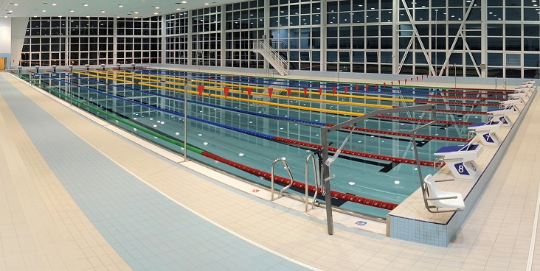

SCPAP IN COOPERATION WITH AQUACENTRUM PARDUBICE
PROUDLY PRESENT THEIR
PARDUBICE GRAND PRIX

Swimming meet staged at the
AQUACENTRUM PARDUBICE (CZE),
Jiráskova 2664, 530 02 Pardubice, Czech republic

GPS: 50°2'1.428"N, 15°46'55.941"E
DATE: 17. 5. -18. 5. 2014
VENUE: 50 meter pool, 8 lanes, 185 cm deep, eletronic timing
AGE CATHEGORY:year of birth 2001 and older
ENTRY FORMS : available www.scpap.cz send to jana.klusackova@aquapce.cz
CLOSING DATE: 6th. May 2014
ENTRY FEES: 3 EURO / EVENT

PRIZES: individual event : 1st place – 800,- Kc
2nd place – 500,- Kc
3rd place – 200,- Kc
The best performance of the competation in men cathegory will be awarded 8 000,- Kc – 5 000,-Kc – 2 000,-Kc
The best performance of the competation in women cathegory will be awarded 8000,- Kc – 5 000,-Kc – 2 000,-Kc

SPECIAL BONUS: accomodation and alimentation for olympionics free.

ACCOMODATION : www.ipardubice.cz/ubytovani/
hotel Zlatá štika www.zlatastika.cz 15 min go on foot
penzion City Café www.penzioncity.cz 15 min go on foot
hotel Sport www.hotelsport.webnode.cz 20 min go on foot
Steak station www.steakstation.cz 5 min car
penzion Šenk www.ubytovani-pardubice.eu 10 min car
hotel Kristl www.hotelkristl.cz 10 min go on foot
INFO: jana.klusackova@aquapce.cz mobile: +420 734 260 392

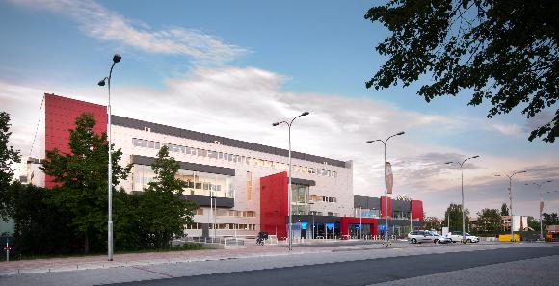.

Saturday 17. 5. 2014 morning - warm up 8.00-.8.50 , competation 9.00
Saturday 17.5.2014 afternoon – warm up 15.30-16.20, competation 16.30 hod

HEATS FINALE
1. 200m Freestyle Men 1a 200m Freestyle Men
2. 200m Freestyle Women 2a 200m Freestyle Women
3. 50m Breastroke Men 3a 50m Breastroke Men
4. 50m Breastroke Women 4a 50m Breastroke Women
5. 200m Backstroke Men 5a 200m Backstroke Men
6. 200m Backstroke Women 6a 200m Backstroke Women
7. 50m Butterfly Men 7a 50m Butterfly Men
8. 50m Butterfly Women 8a 50m Butterfly Women
9. 200m Breastroke Men 9a 200m Breastroke Men
10. 200m Breastroke Women 10a 200m Breastroke Women
11. 50m Backstroke Men 11a 50m Backstroke Men
12. 50m Backstroke Women 12a 50m Backstroke Women
13. 200m Butterfly Men 13a 200m Butterfly Men
14. 200m Butterfly Women 14a 200m Butterfly Women
15. 50m Freestyle Men 15a 50m Freestyle Men
16. 50m Freestyle Women 16a 50m Freestyle Women
17. 200m Ïndividual Medley Men 17a 200m Ïndividual Medley Men
18. 200m Individual Medley Women 18a 200m Individual Medley Women
19. 4x50m Individual Medley Mix 22. 4x50m free style Mix
20. 800m Freestyle Men (1 Heat) 23. 1500m Freestyle Men (1 Heat)
21. 1500m Freestyle Women (1 Heat) 24. 800m Freestyle Women (1 Heat)

SUNDAY 18. 5. 2014 morning - warm up 8.00-8.50 , competation 9.00
SUNDAY 18.5. 2014 afternoon – warm up 14.00-14.50, competation 15.00 hod
HEATS FINALE

25. 400m Individual Medley Men 25a 400m Individual Medley Men
26. 400m Individual Medley Women 26a 400m Individual Medley Women
27. 100m Butterfly Men 27a 100m Butterfly Men
28. 100m Butterfly Women 28a 100m Butterfly Women
29. 100m Breastroke Men 29a 100m Breastroke Men
30. 100m Breastroke Women 30a 100m Breastroke Women
31. 100m Freestyle Men 31a 100m Freestyle Men
32. 100m Freestyle Women 32a 100m Freestyle Women
33. 100m Backstroke Men 33a 100m Backstroke Men
34. 100m Backstroke Women 34a 100m Backstroke Women
35. 400m Freestyle Men 35a 400m Freestyle Men
36. 400m Freestyle Women 36a 400m Freestyle Women

men women

50 free Plevko Tomáš SkŽat 0:23,10 Dostálová Sabina SPSw 0:25,83
100 free Verner Martin KomBr 0:51,18 Dostálová Sabina SPSw 0:56,79
200 free Micka Jan USK 1:51,31 Závadová Barbora KPSOs 2:02,93
400 free Micka Jan USK 3:54,53 Benešová Alena KIN 4:25,28
800 free Micka Jan USK 8:04,14 Benešová Alena KIN 9:06,00
1500 free Novoveský Tomáš KIN 16:04,59 Elhenická Martina LoTr 17:24,41
50 fly Plevko Tomáš SkŽat 0:24,80 Svěcená Lucie SkŽat 0:27,31
100 fly Šefl Jan SlPl 0:54,34 Svěcená Lucie SkŽat 1:00,72
200 fly Šefl Jan SlPl 2:00,83 Benešová Alena KIN 2:18,79
50 back Baďura Martin KPSOs 0:26,28 Řehořková Alžběta Boh 0:29,59
100 back Baďura Martin KPSOs 0:58,27 Baumrtová Simona SlCho 1:00,29
200 back Vlčan Luboš JPK 2:04,37 Slámová Klára JPK 2:26,18
50 breastroke Bartůněk Petr CHÚ 0:28,27 Chocová Petra PKČL 0:30,71
100 breastroke Bartůněk Petr CHÚ 1:04,03 Chocová Petra PKČL 1:08,59
200 breastroke Bartůněk Petr CHÚ 2:20.82 Moravčíková Martina Boh 2:30,47
200 IM Zikmund Martin KSPKl 2:08,06 Závadová Barbora KPSOs 2:17,11
400 IM Tobiáš Jakub KomBr 4:36,02 Elhenická Martina LoTr 4:58,93

4x50 free Zlínský plavecký klub 1:39,52 SK Motorlet Praha 1:50,65

